Load Testing

Here we have performed the load testing **in Jmeter**.

A **Jmeter** Test Plan must have listener to showcase the result of performance test execution.

* Listeners capture the response coming back from Server while **Jmeter** runs and showcase in the form of – tree, tables, graphs and log files.
* It also allows you to save the result in a file for future reference. There are many types of listeners **Jmeter** provides. Some of them are: Summary Report, Aggregate Report, Aggregate Graph, View Results Tree, View Results in Table etc.

Here is the detailed understanding of each parameter in Summary report.

* **Label:** It is the name/URL for the specific HTTP(s) Request. If you have selected “Include group name in label?” option then the name of the Thread Group is applied as the prefix to each label.
* **Samples:** This indicates the number of virtual users per request.
* **Average:** It is the average time taken by all the samples to execute specific label.
* **Min:** The shortest time taken by a sample for specific label.
* **Max:** The longest time taken by a sample for specific label.
* **Std. Dev.:** This shows the set of exceptional cases which were deviating from the average value of sample response time. The lesser this value more consistent the data. Standard deviation should be less than or equal to half of the average time for a label.
* **Error%:** Percentage of Failed requests per Label.
* **Throughput:** Throughput is the number of requests that are processed per time unit (seconds, minutes, hours) by the server. This time is calculated from the start of first sample to the end of the last sample. Larger throughput is better.
* **KB/Sec:** This indicates the amount of data downloaded from server during the performance test execution. In short, it is the Throughput measured in Kilobytes per second.

**Test – HTTP GET Request of all the pages**

Web-Pages:

1. Dashboard
2. Profile
3. Stock Info
4. Login
5. Landing

# Dashboard Page

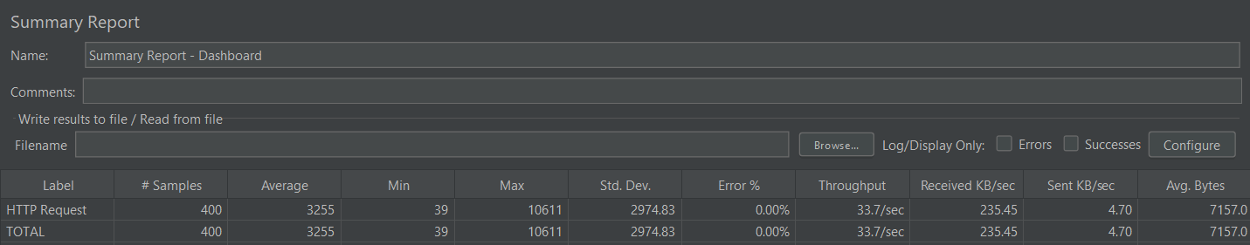

|  |  |  |  |  |  |
| --- | --- | --- | --- | --- | --- |
| Number of Users | Ramp-up Period | Loop Count | Total Samples  (Users*Loops) | Average Error(In %) | Throughput  (Response/s) |
| 200 | 2 | 2 | 400 | 0 | 33.7 |
| 400 | 2 | 2 | 800 | 7.12 | 11.1 |
| 600 | 2 | 2 | 1200 | 44.8 | 14 |

# Profile Page



|  |  |  |  |  |  |
| --- | --- | --- | --- | --- | --- |
| Number of Users | Ramp-up Period | Loop Count | Total Samples  (Users*Loops) | Average Error(In %) | Throughput  (Response/s) |
| 200 | 2 | 2 | 400 | 0 | 36.5 |
| 400 | 2 | 2 | 800 | 8.25 | 11.6 |
| 600 | 2 | 2 | 1200 | 56.08 | 14 |

# StockInfo Page



|  |  |  |  |  |  |
| --- | --- | --- | --- | --- | --- |
| Number of Users | Ramp-up Period | Loop Count | Total Samples  (Users*Loops) | Average Error(In %) | Throughput  (Response/s) |
| 200 | 2 | 2 | 400 | 0 | 80.6 |
| 400 | 2 | 2 | 800 | 13 | 9.3 |
| 600 | 2 | 2 | 1200 | 65.08 | 13.9 |

# Login Page



|  |  |  |  |  |  |
| --- | --- | --- | --- | --- | --- |
| Number of Users | Ramp-up Period | Loop Count | Total Samples  (Users*Loops) | Average Error(In %) | Throughput  (Response/s) |
| 200 | 2 | 2 | 400 | 0 | 61.3 |
| 400 | 2 | 2 | 800 | 9.62 | 11.7 |
| 600 | 2 | 2 | 1200 | 48.5 | 12.7 |

# Landing Page



|  |  |  |  |  |  |
| --- | --- | --- | --- | --- | --- |
| Number of Users | Ramp-up Period | Loop Count | Total Samples  (Users*Loops) | Average Error(In %) | Throughput  (Response/s) |
| 200 | 2 | 2 | 400 | 0 | 4.5 |
| 400 | 2 | 2 | 800 | 10.9 | 7 |
| 600 | 2 | 2 | 1200 | 48.45 | 4.6 |

# Average Analysis:

|  |  |  |  |  |  |
| --- | --- | --- | --- | --- | --- |
| Number of Users | Ramp-up Period | Loop Count | Total Samples  (Users*Loops) | Average Error(In %) | Throughput  (Response/s) |
| 200 | 2 | 2 | 400 | 0 | 43.32 |
| 400 | 2 | 2 | 800 | 9.78 | 10.14 |
| 600 | 2 | 2 | 1200 | 52.58 | 11.84 |